ECEN 325

Lab 2: Second Order Circuits

Section 506

02/06/2020

Jason Gilman

TA: Mandela

**Introduction:**

In this lab, we constructed three second order circuits. One resembled a low-pass filter, one a high-pass filter, and the other a band-pass filter. We then produced and analyzed the bode and time-domain waveforms to collect information on the circuits.

**Calculations:**

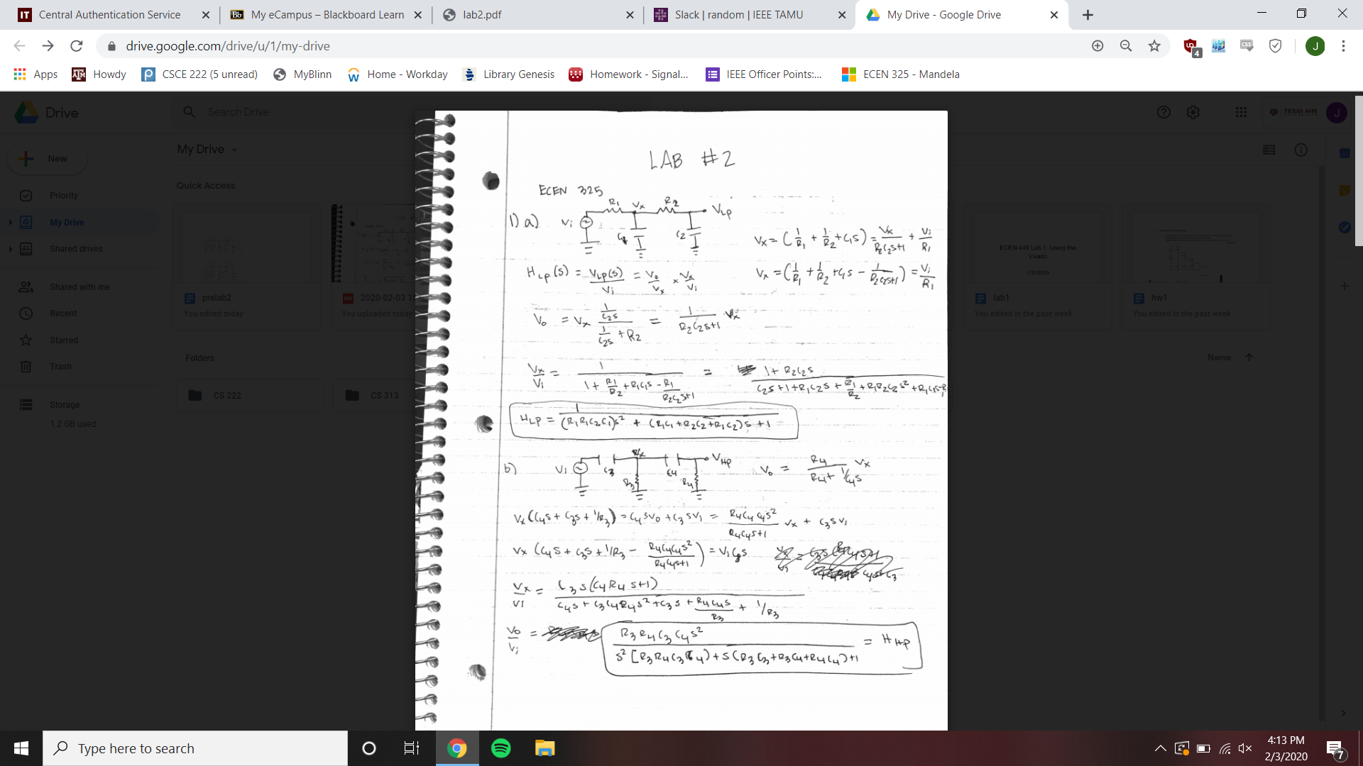

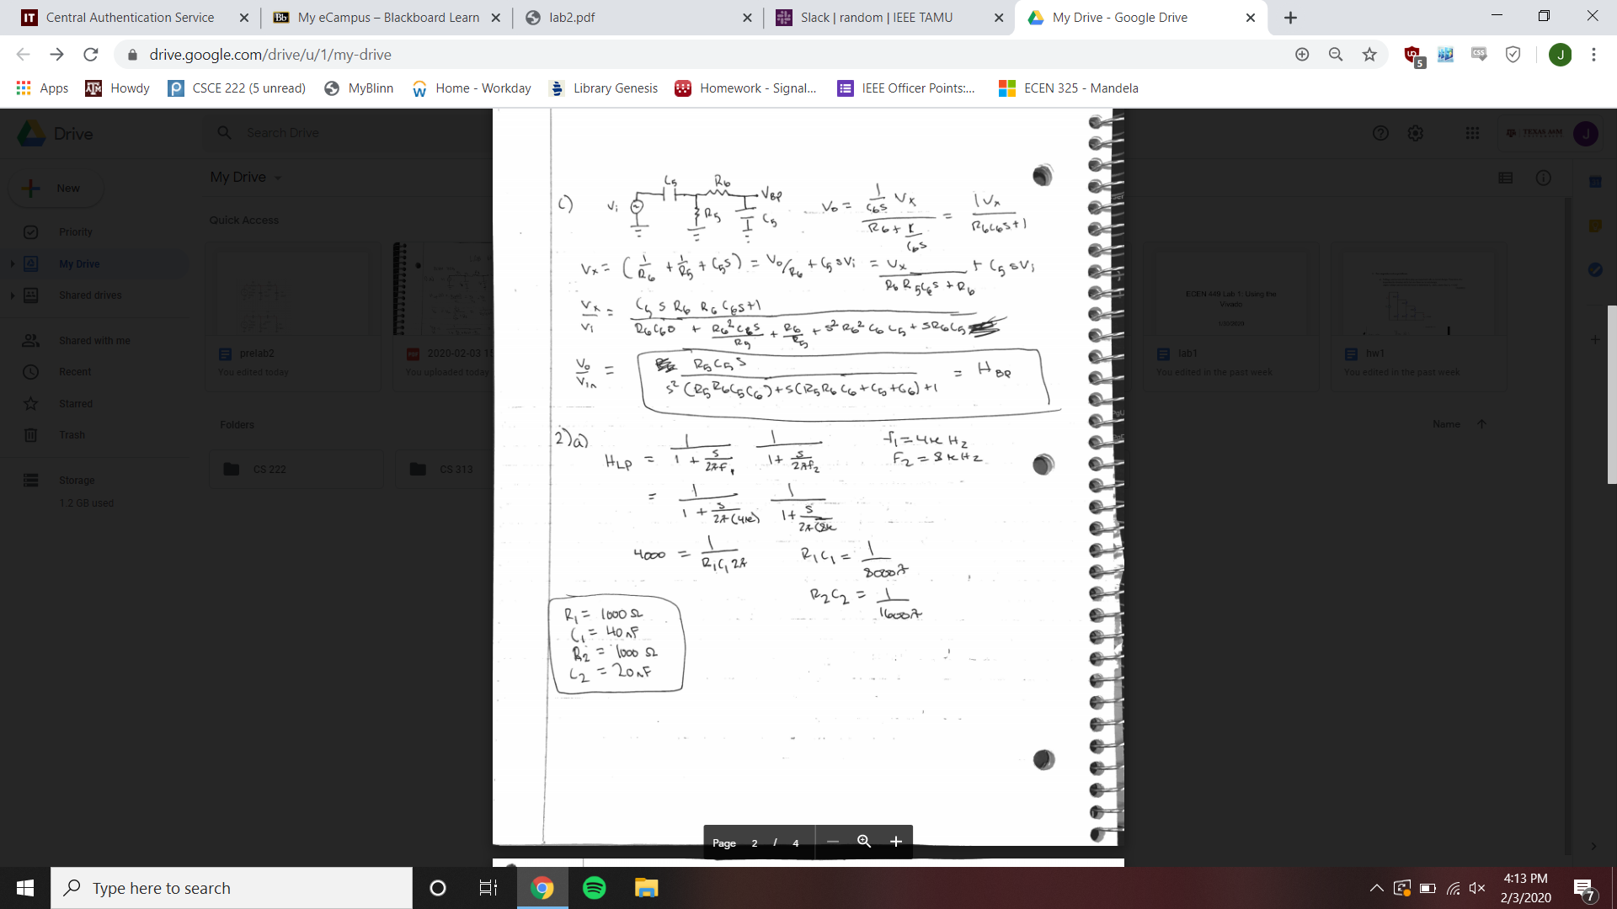

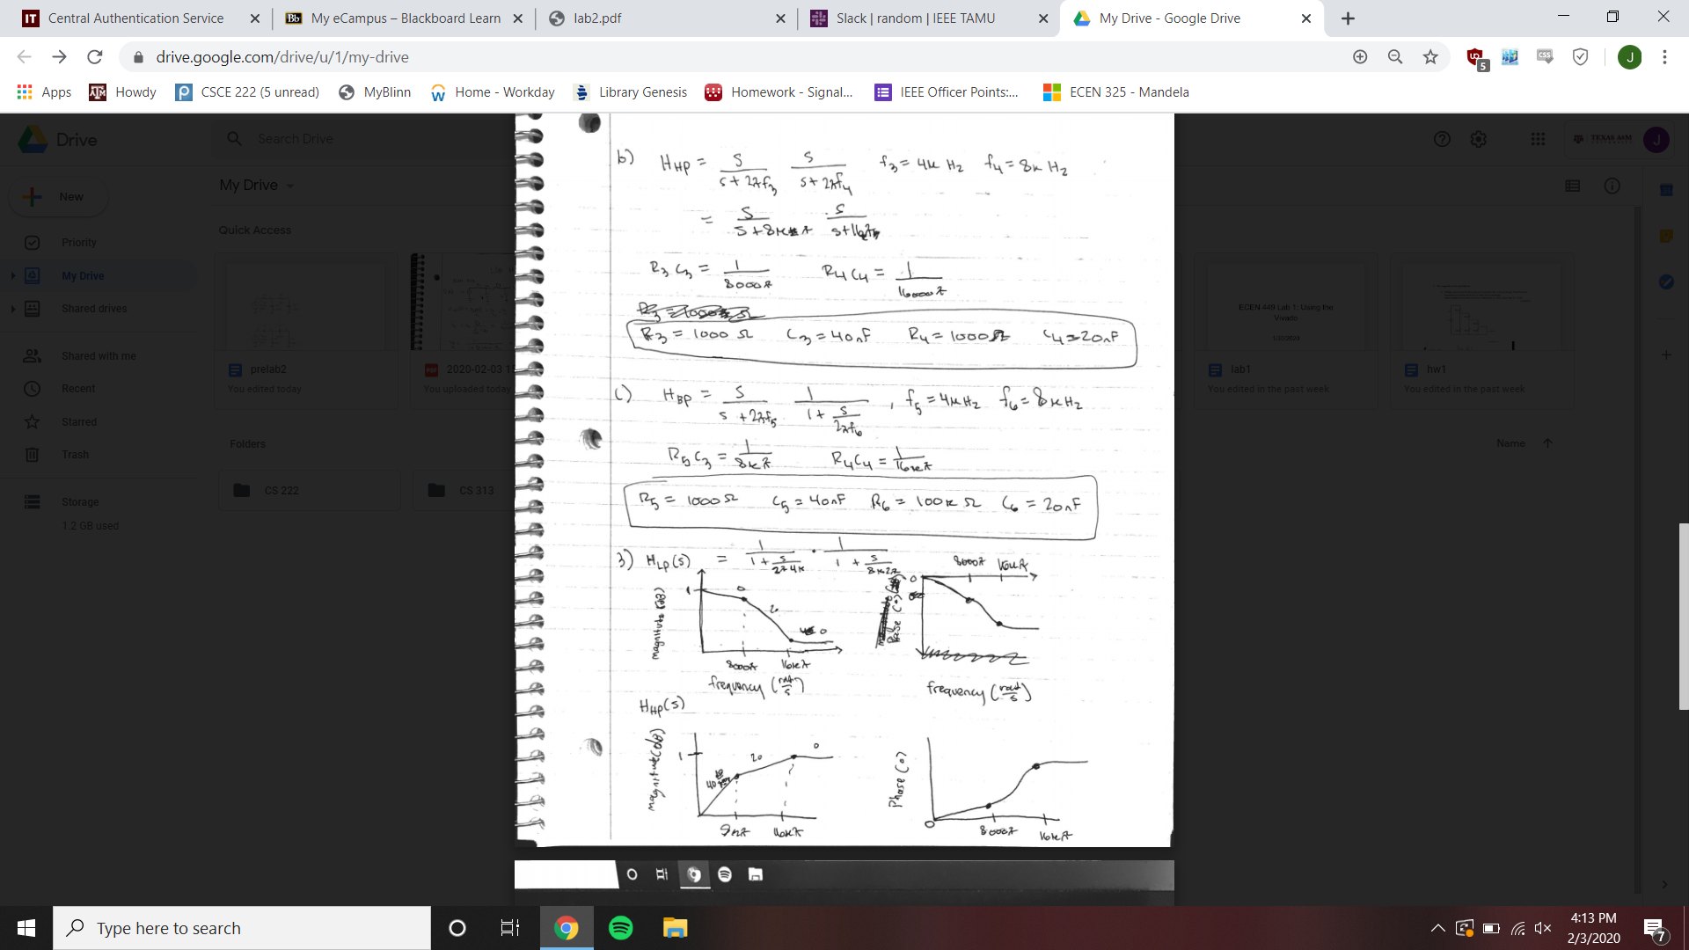

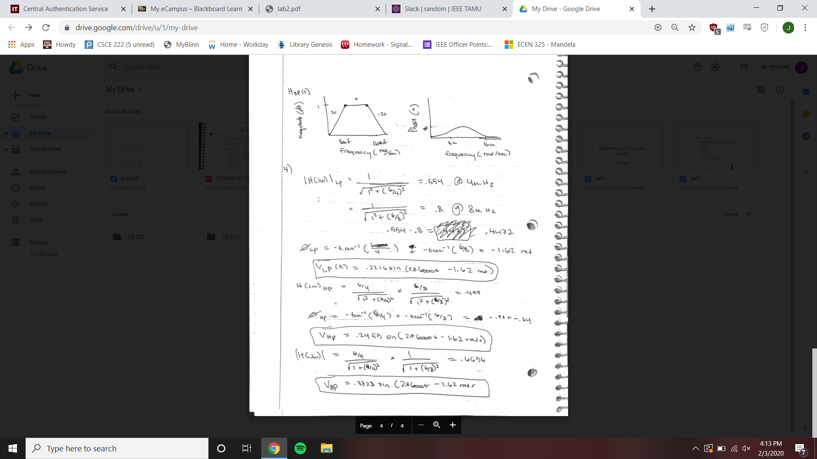

**Schematics:**

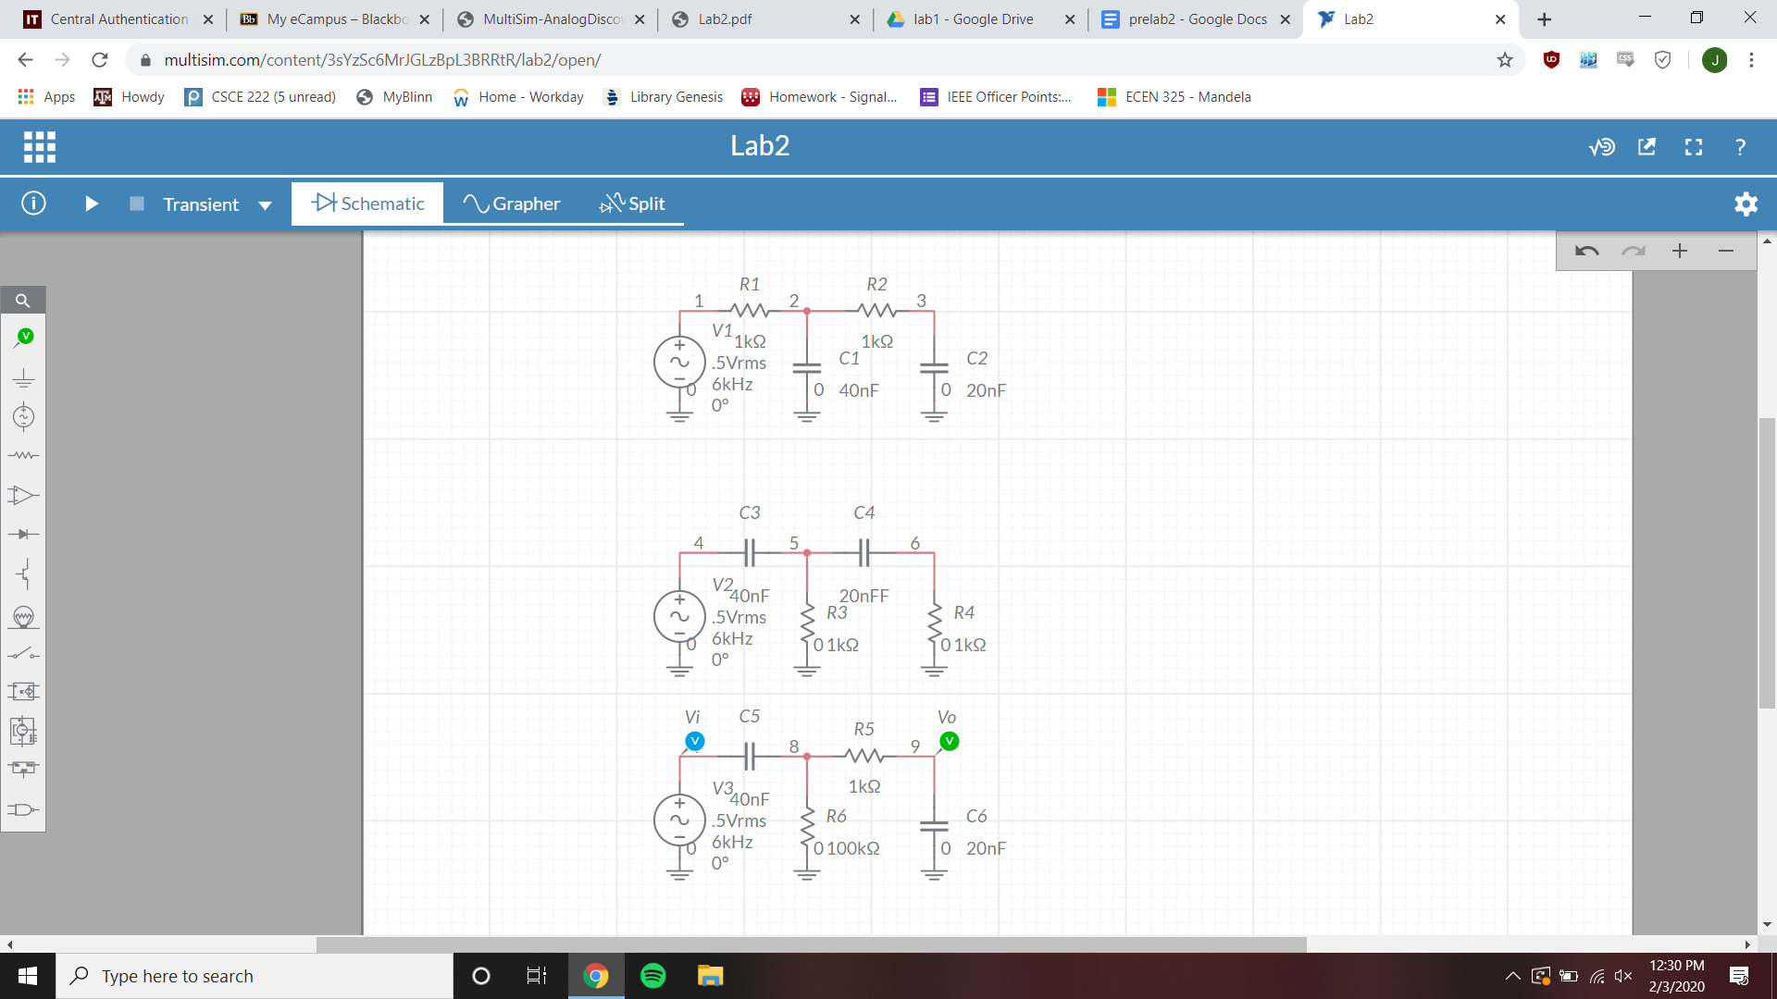

**Simulations:**

Low-pass Bode Simulation

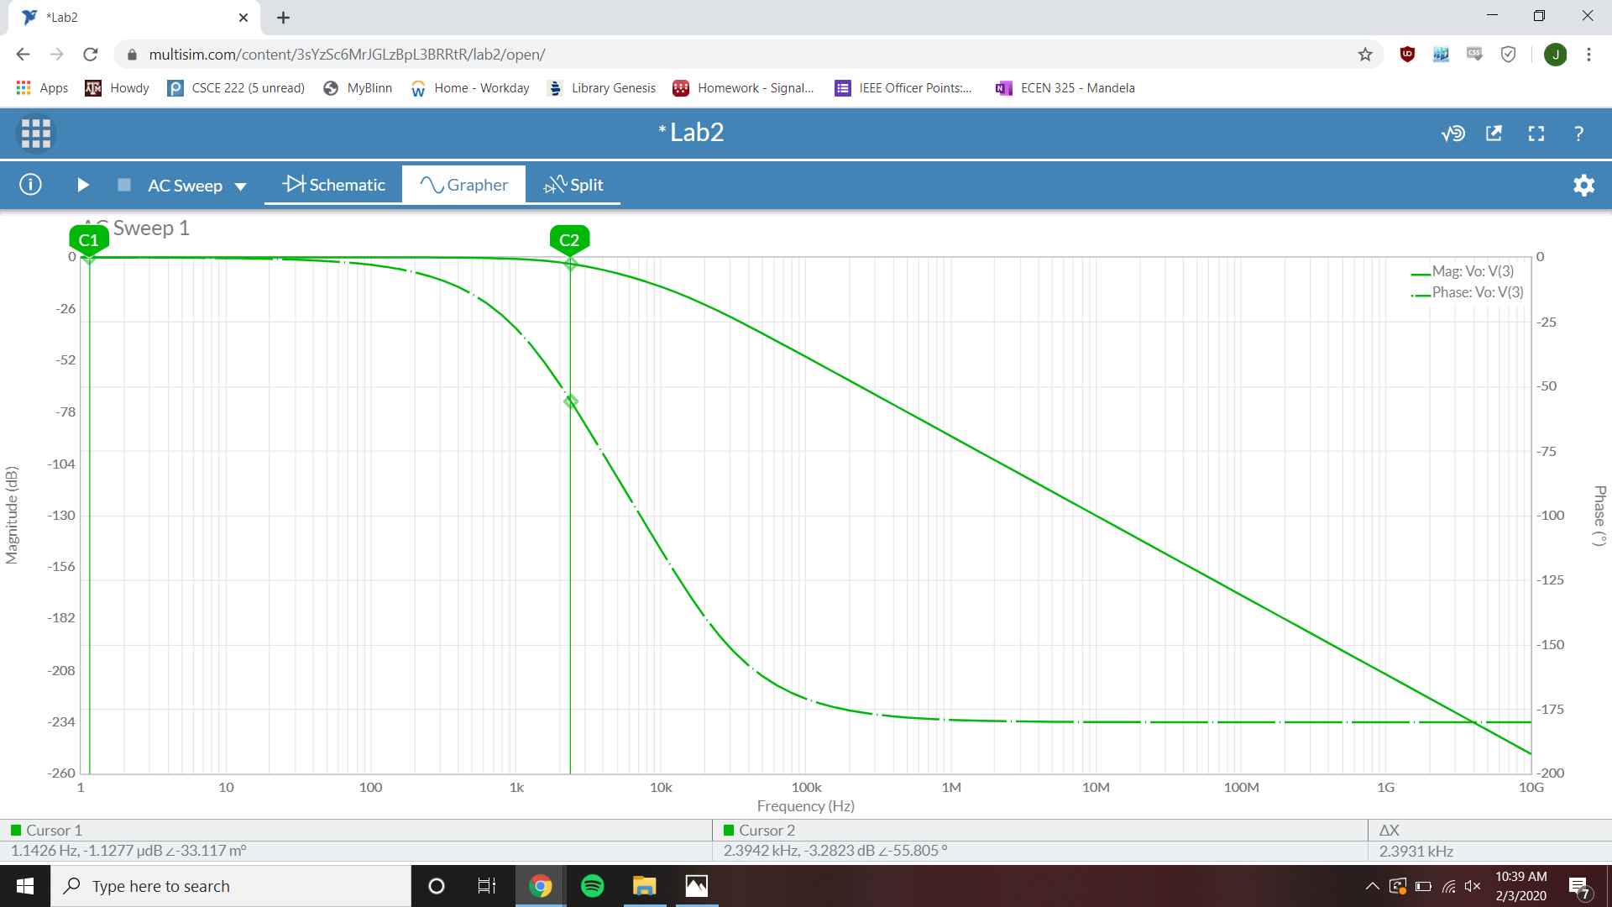

3 dB frequency = 2.3931 kHz

Passband gain = -1.1277 µdB

Magnitude @ f=6k Hz = -10.054 dB

Phase @ f=6k Hz = -94.639°

High-pass Bode Simulation

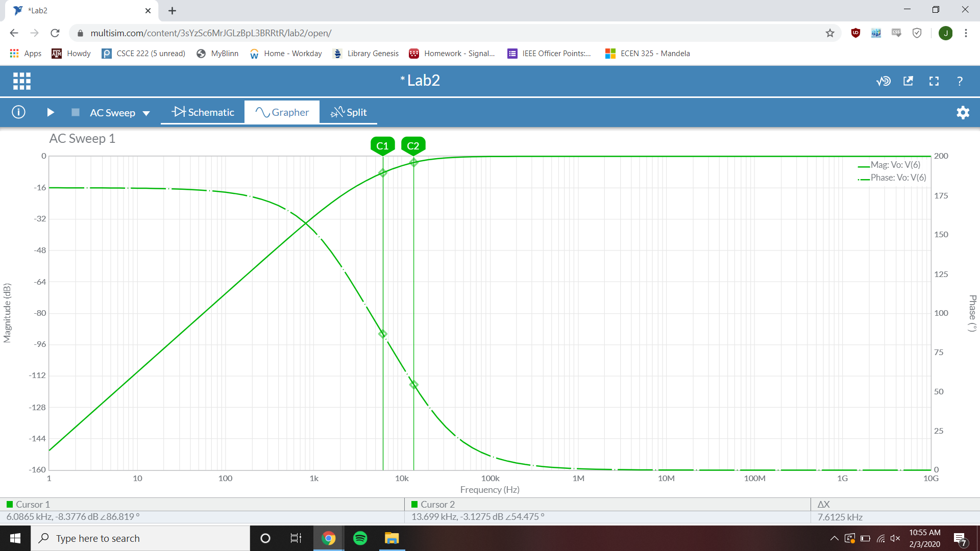

3dB frequency = 13.699 kHz

Passband gain = -2.7626 µdB

Magnitude @ f=6k Hz = -8.3717 dB

Phase @ f=6k Hz = 86.792°

Band-pass Bode Simulation

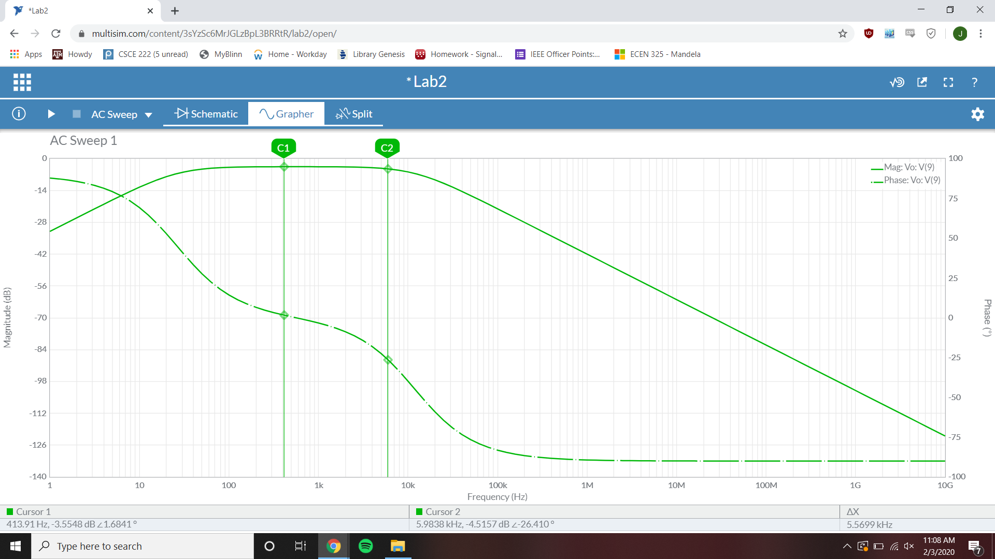

3dB frequency = 413.91 Hz

Passband gain = -3.5548 dB

Magnitude @ f=6k Hz = -4.5157 dB

Phase @ f=6k Hz = -26.410°

Low-pass Time-Domain Simulation

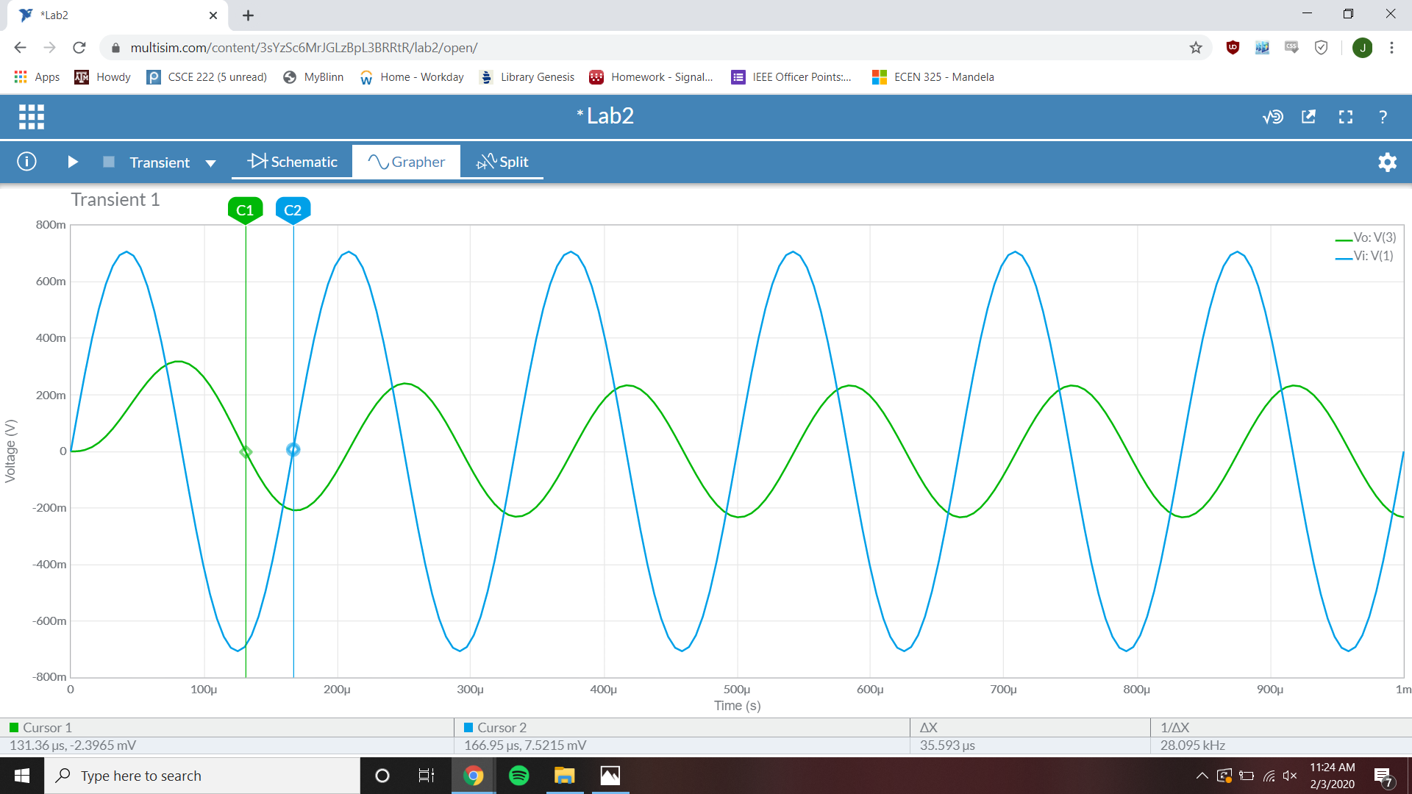

Phase difference = -76.8744°

Vi Magnitude = 706.22 mV

Vo Magnitude = 318 mV

High-pass Time-Domain Simulation

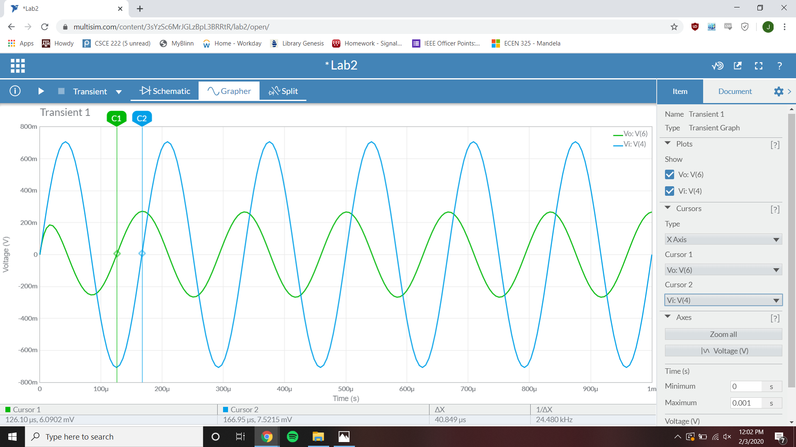

Phase difference = 88.236°

Vi Magnitude = 706 mV

Vo Magnitude = 270.83 mV

Band-pass Time-Domain Simulation

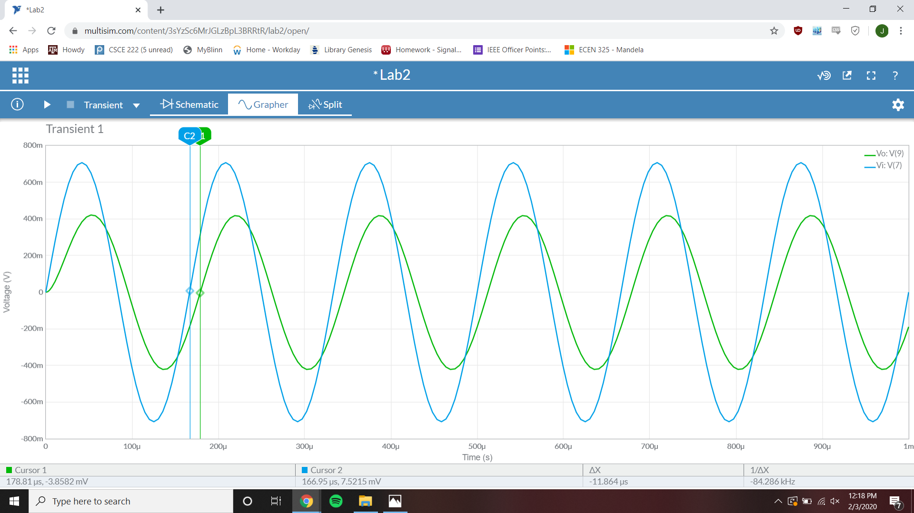

Phase difference = -25.73°

Vi Magnitude = 706 mV

Vo Magnitude = 417.2 mV

**Measurements:**

Low-pass Bode plot

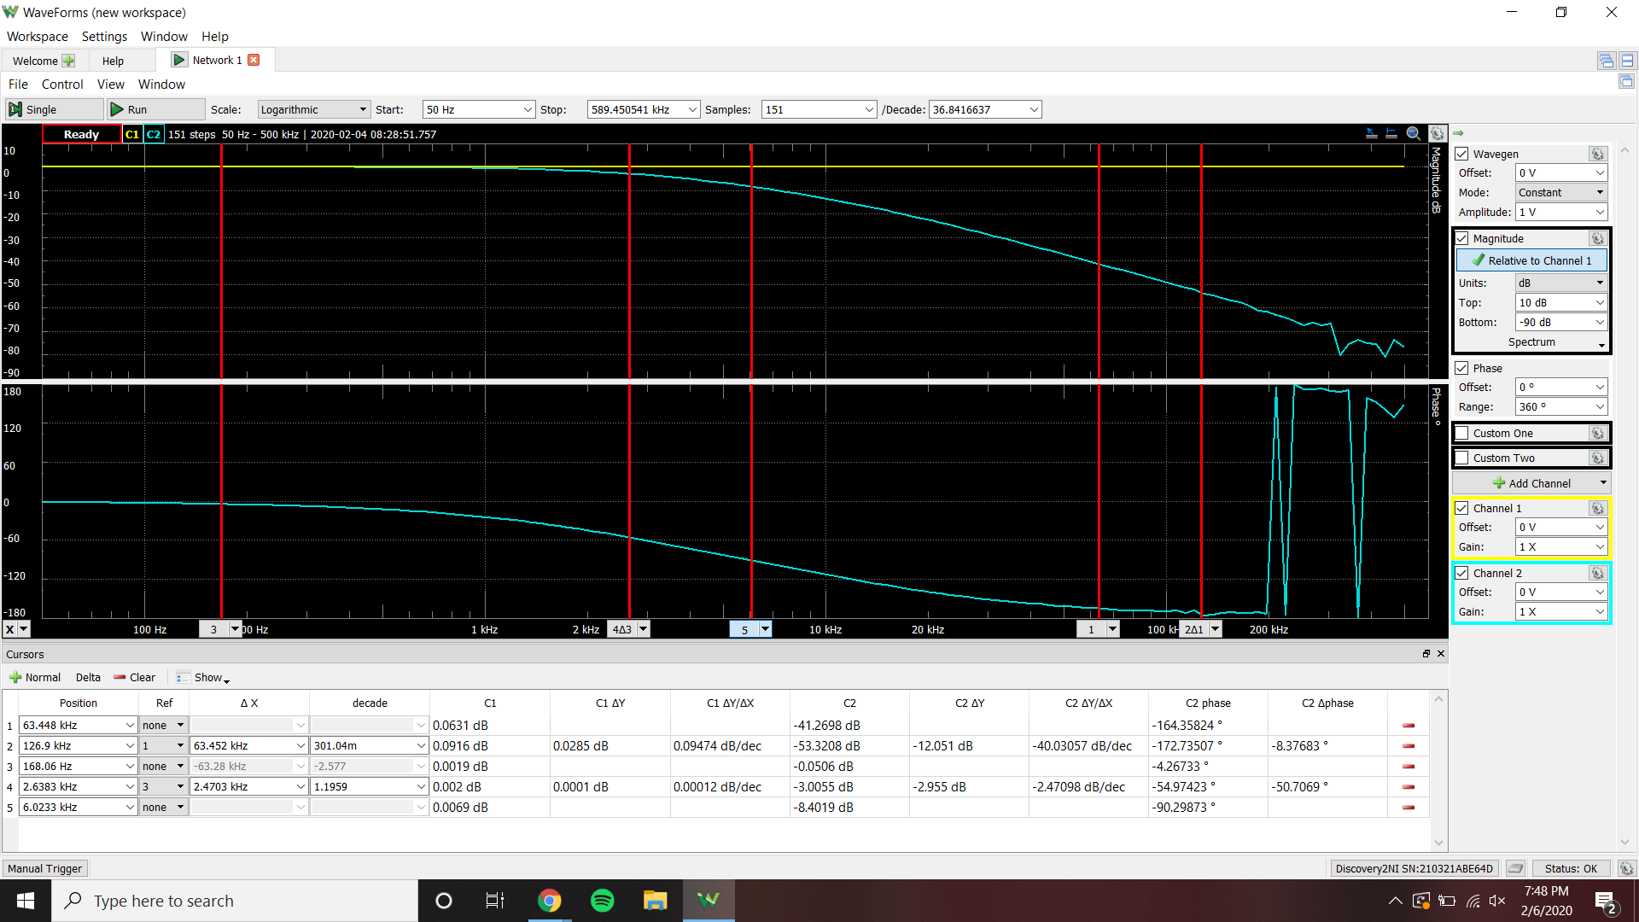

Passband gain = -0.0506 dB 3 dB frequency = 2.6383 kHz

6k Hz magnitude = -8.4019 dB 6k Hz phase = -90.29873°

High-pass Bode plot

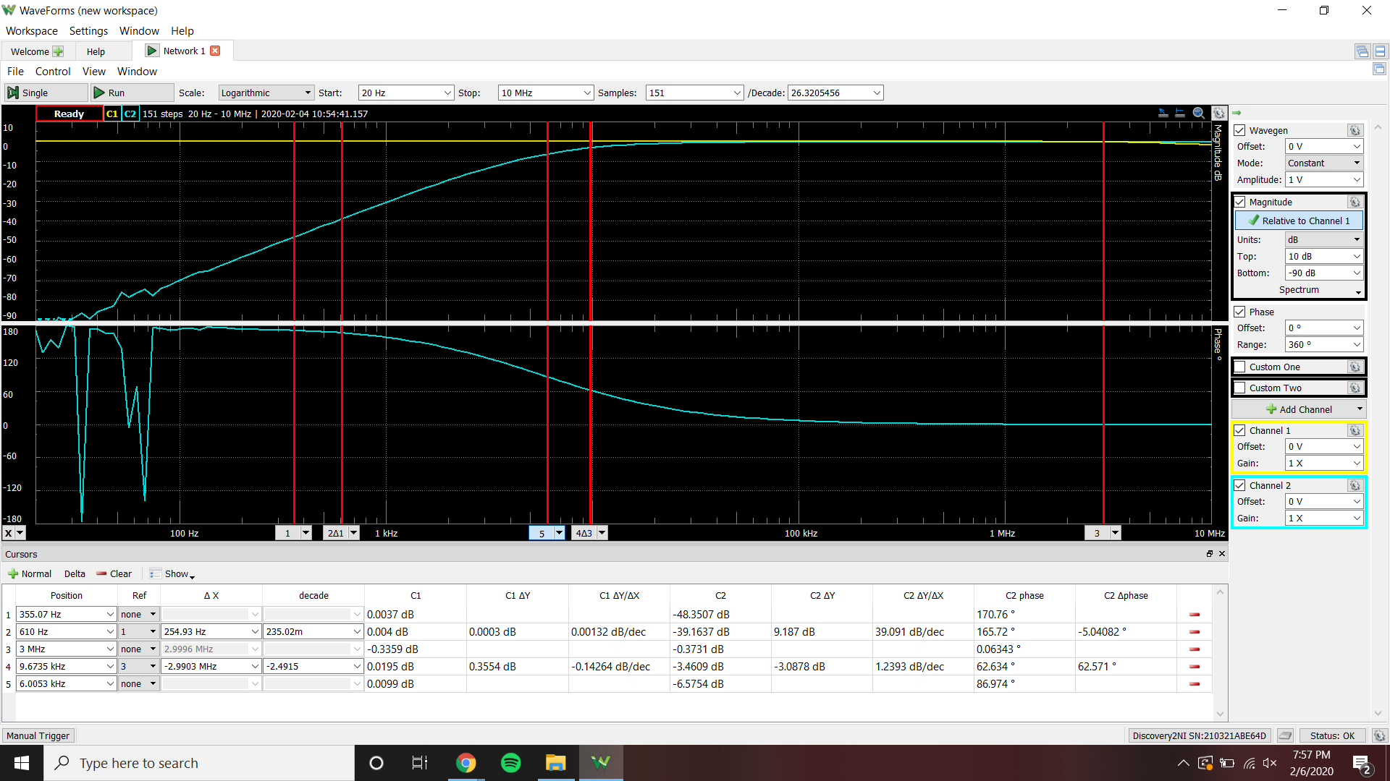

Passband gain = -0.3731 dB 3 dB frequency = 9.6735 kHz

6k Hz magnitude = -6.5754 dB 6k Hz phase = 86.974°

Band-pass Bode plot

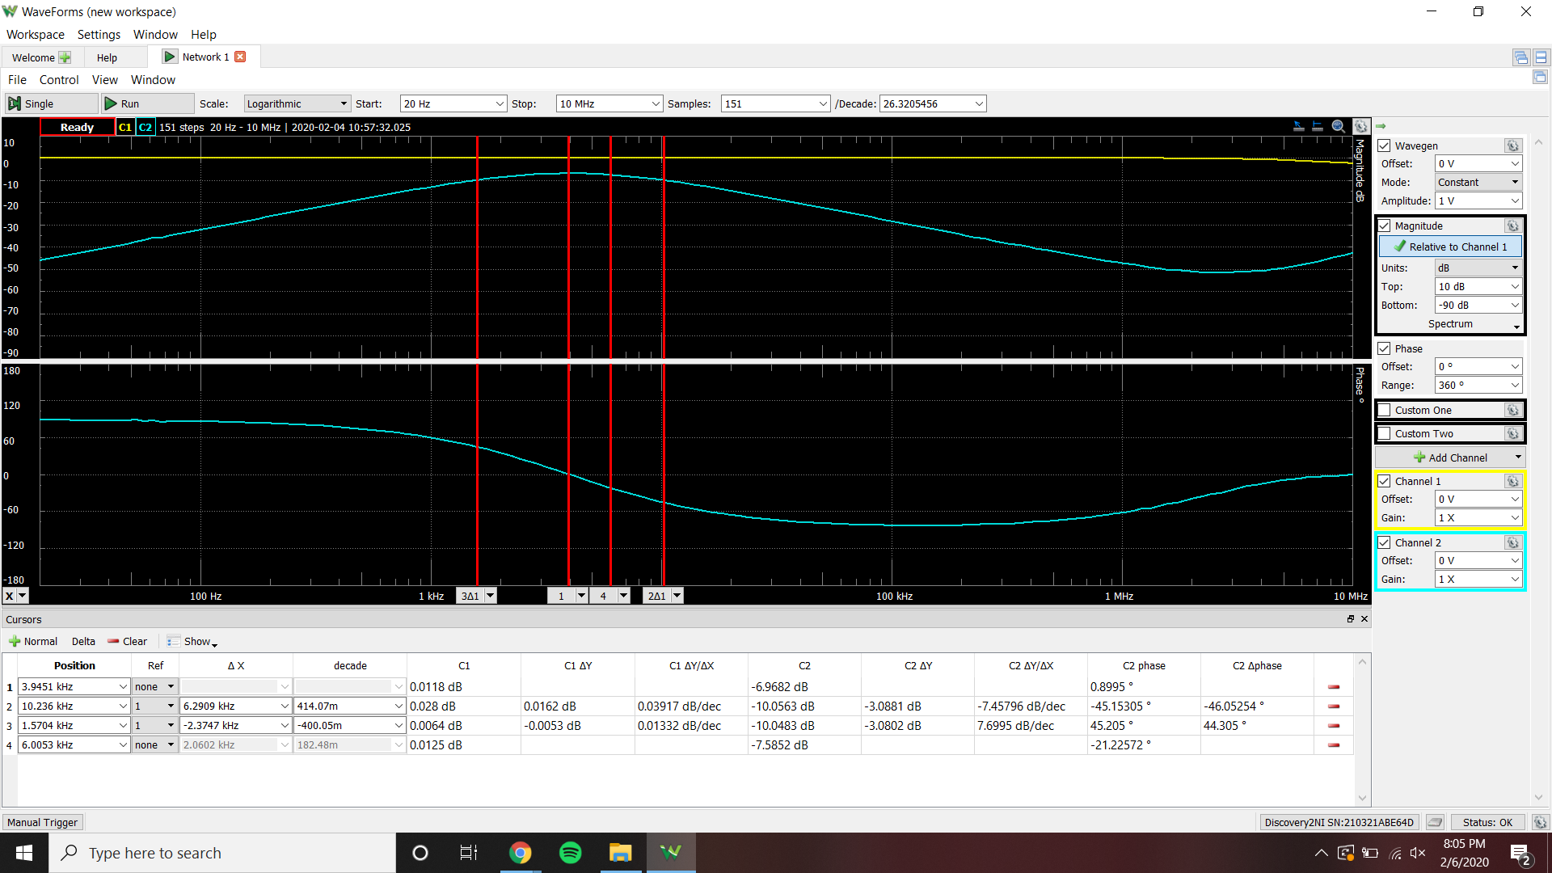

Passband gain = -6.9682 dB 3 dB frequency = 1.5704 kHz 10.236 kHz

6k Hz magnitude = -7.5852 dB 6k Hz phase = -21.22572°

Low-pass Time-Domain plot

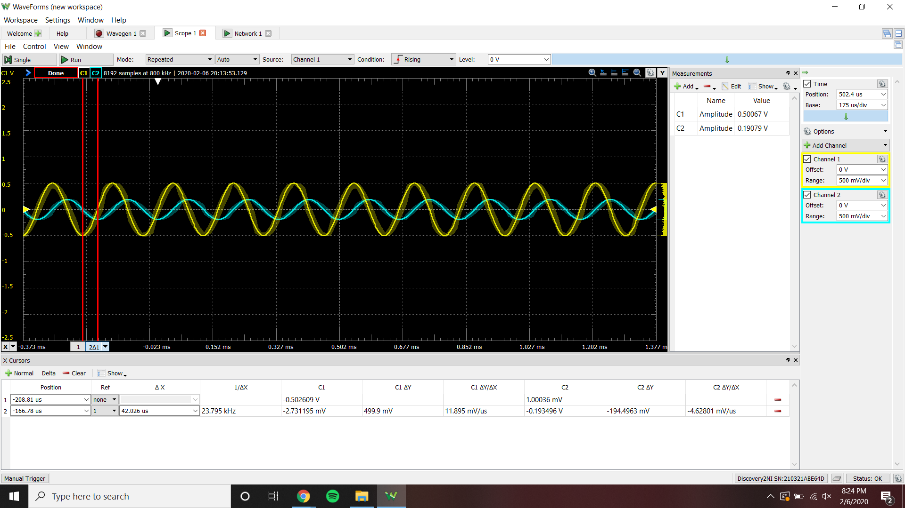

Vi magnitude = 0.50067 V Vo magnitude = 0.19079 V

Phase difference = -88.452°

High-pass Time-Domain plot

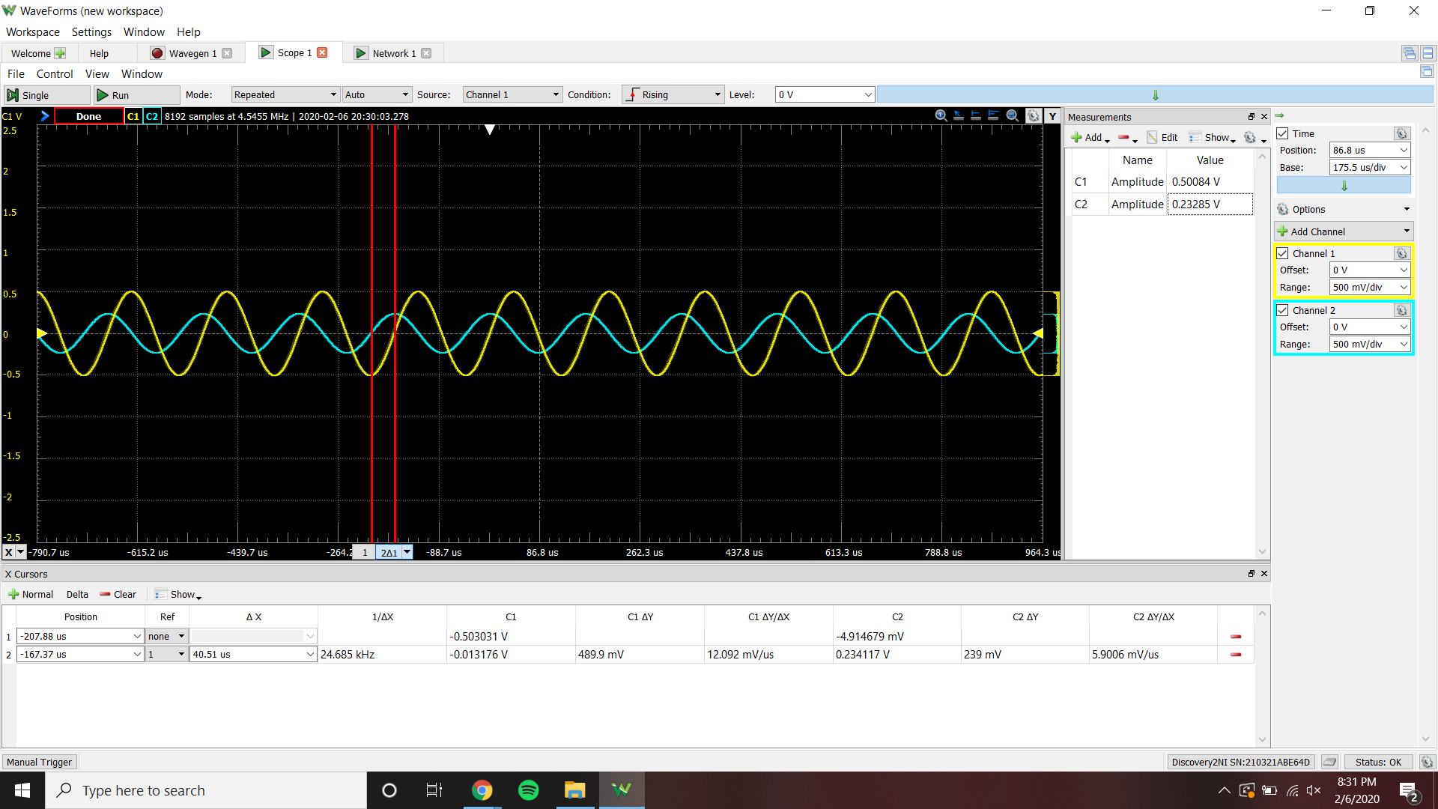

Vi magnitude = 0.50084 V Vo magnitude = 0.23285 V

Phase difference = 87.5016°

Band-pass Time-Domain plot

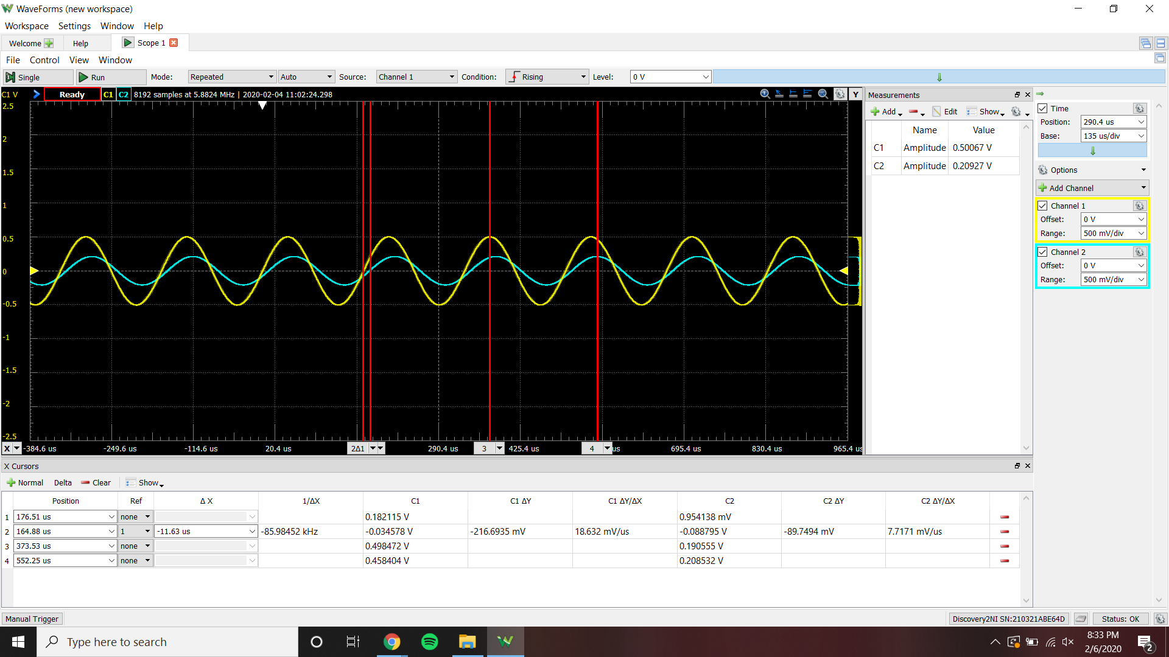

Vi magnitude = 0.50067 V Vo magnitude = 0.20927 V

Phase difference = -25.1208°

|  |  |
| --- | --- |
|  | Vi(t)=.5sin(2pi6000t) |
| Magnitude, Calculated, Low-Pass | -7.068 dB |
| Magnitude, Simulated, Low-Pass | -10.054 dB |
| Magnitude, Measured, Low-Pass | -8.4019 dB |
| Phase, Calculated, Low-Pass | -92.81916° |
| Phase, Simulated, Low-Pass | -94.639° |
| Phase, Measured, Low-Pass | -90.29873° |
| Magnitude, Calculated, High-Pass | -6.03799 dB |
| Magnitude, Simulated, High-Pass | -8.3717 dB |
| Magnitude, Measured, High-Pass | -6.5754 dB |
| Phase, Calculated, High-Pass | -92.81916° |
| Phase, Simulated, High-Pass | 86.792° |
| Phase, Measured, High-Pass | 86.974° |
| Magnitude, Calculated, Band-Pass | -3.53573 dB |
| Magnitude, Simulated, Band-Pass | -4.5157 dB |
| Magnitude, Measured, Band-Pass | -7.5852 dB |
| Phase, Calculated, Band-Pass | -92.81916° |
| Phase, Simulated, Band-Pass | -26.410° |
| Phase, Measured, Band-Pass | -21.22572° |

**Conclusion:**

The results between calculated, simulated, and measured have some differences in values. The calculated and measured results are more similar compared to the simulated results. This is because the transfer function was derived by approximations. The cascaded transfer function was not taken into account in the equation, because the second order of low-pass, high-pass, or band-pass was drawing current away from the first order. This affects the result of the true transfer function, because you miss out on the exact equation that is represented by the circuit. When finding the component values from the transfer function using approximations, the components needed to satisfy the following equation - R(i+1)C(i+1) = 1/8000pi or R(i)C(i) = 1/1600pi. I chose the component values based off of the capacitor values we were given in our lab kit. I then combined resistor values in series and parallel to achieve the desired circuit. If i were to do the opposite, by choosing resistor values in the lab kit then combining capacitors, the circuit would have been much harder to put together, because I may not be able to make a certain value.